**Develop A Web Application Using Node-RED**

Steps Followed:

● Opened a Node-RED project

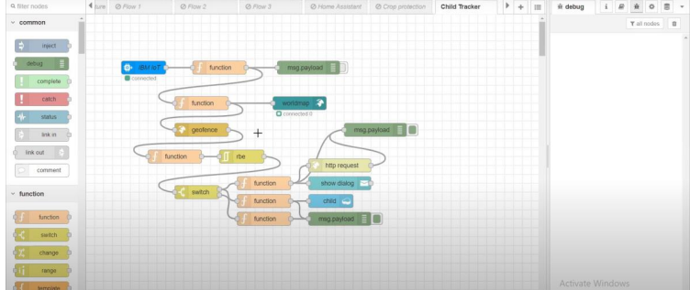

● Added code to get child location in python

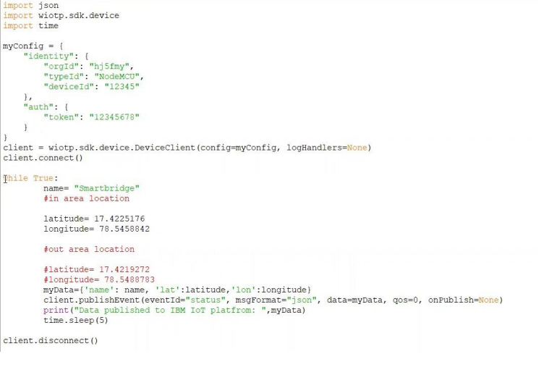

● Created the GeoFence

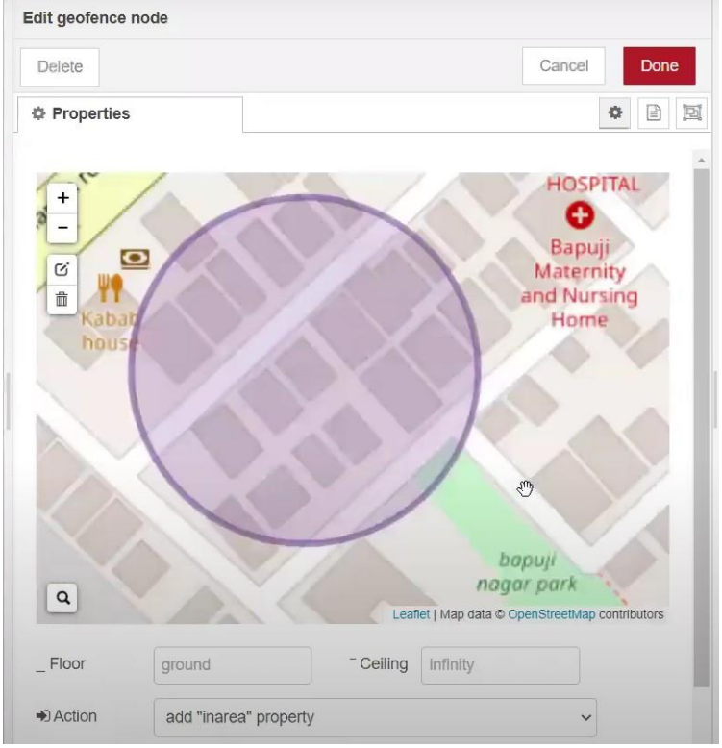

● Editing the HTTP Request URL

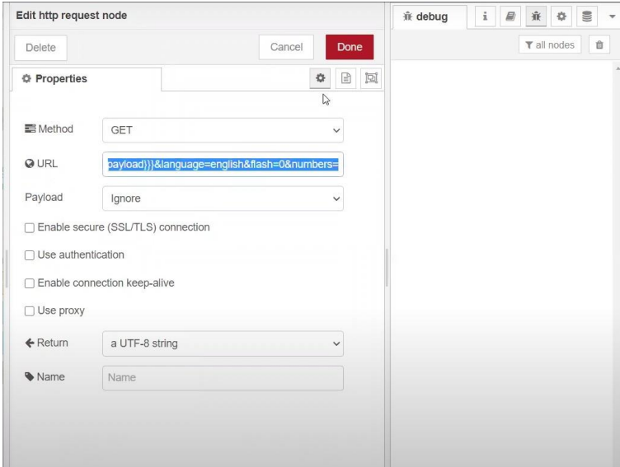

● Located the child

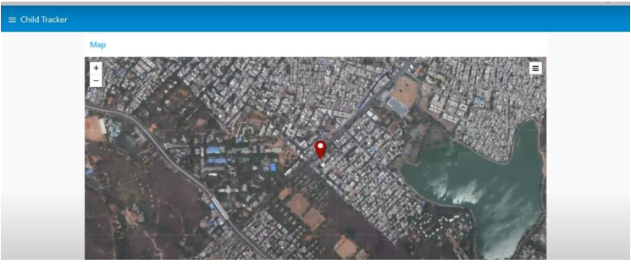

● Created the geofence node

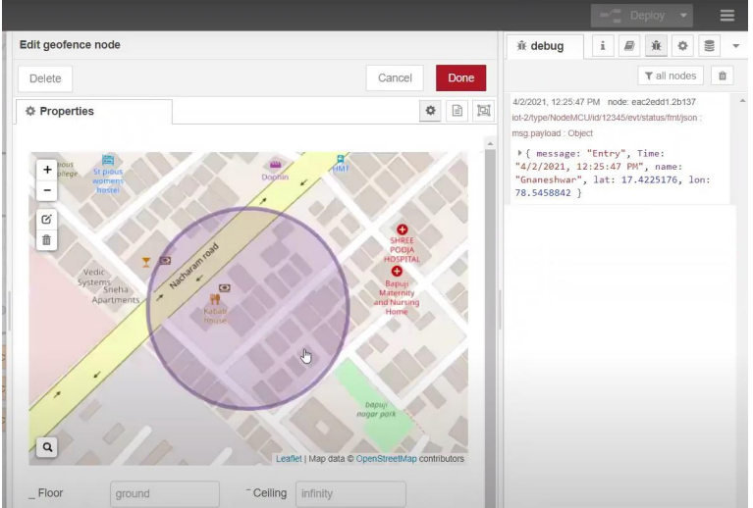

● Python script sending requests to IBM Cloud

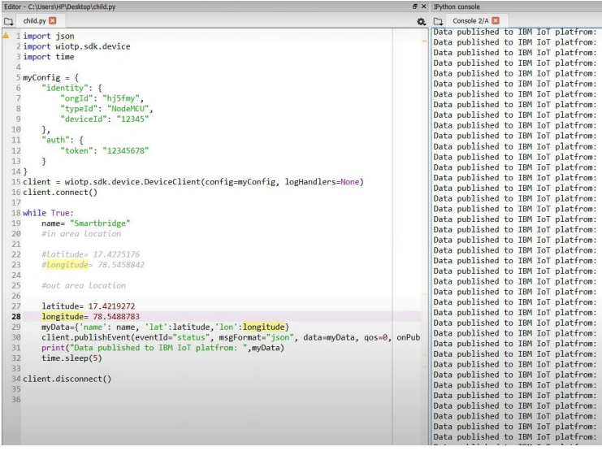

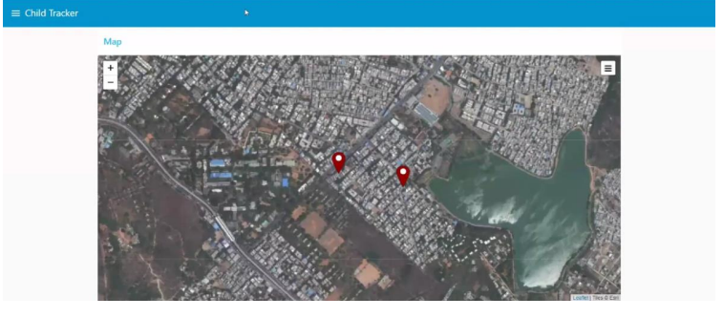● After running the script, the web UI shows “Person is not in the particular area”

Result: Successfully developed a web application using Node-RED